CSC 4350 Software Engineering

Fall 2017

Deliverable 2

**Group Name:** CHHAP

**Group Members:** Chris Kazenske, Aqsa Sohail, Hena Shah, Parita Malbari, Hafsah Uddin

September 22nd, 2017

**Introduction: Magic Mirror**

The Magic Mirror shall run behind a 2-way mirror to create the feel of a Smart Mirror. It shall run on a Raspberry Pi, a very lightweight computer that runs the Raspbian operating system. The code shall be written in Java, allowing it to be run on different operating systems. The Magic Mirror shall also use a gesture sensor to make it more user friendly. The gesture sensor shall recognize many gestures performed by a user in order to allow the user to customize appearance, change screens, and control many other aspects of the display. Examples of different gestures are: swipe up, swipe down, swipe right, swipe left, clockwise circles, and counterclockwise circles. It shall have a motion sensor that will detect motion in the room and display the screen when the person is in range. The display device shall be an LCD monitor with the ability to go to sleep mode in order for the system to enter a “power saving” mode when no one is present in the room. The system shall turn the display on automatically when a user enters the room and stands in front of the mirror.

The mirror shall display many features including a clock, up to date weather, news, stocks, and many others. The data shall come from various online API’s. The clock feature shall display either standard or military time and analog or digital based on the user’s preference. The user shall also be able to change the color of the clock to his or her preference.  The preferences shall be set based on a “Preferences” tab which shall be accessible through the use of gestures. The program shall automatically locate the location of the mirror when the program runs based on IP address obtained from the network, allowing the clock to display the correct time based on the time zone.  The weather display shall display the current temperature, forecasted temperature, sunrise and sunset times. It shall also automatically display the weather based on current location, which is determined by the program at runtime. It shall also show weather conditions, like sunny, raining, cloudy, snowing, etc. The weather data shall be updated every 5 minutes automatically. The mirror shall display suggested outfits based on the weather by displaying images of clothing items to wear that day. The news feature shall display hot headlines from various news sources. The news sources shall be varied so the user sees different kinds of headlines. For example, there shall be headlines for world news, entertainment, sports, technology, etc. The user shall have the ability to change between different sources by using gestures.  The stocks page shall display various stock info like top daily and weekly stocks. The calendar page shall display a Google calendar and allow the user to link their personal calendar and get info about the events stored in their calendar. The user shall be able to choose between a daily, weekly, and monthly calendar display. Each main display (news, weather, stocks, and calendar) shall be changed using gestures. The user shall swipe left or right in front of the sensor in order to switch between these different displays. The user shall be able to use this on a day to day basis for their daily routine.

This software shall provide easy accessibility to all the apps such as weather, clock, calendar, news, and stocks that you have on your phone into one product, all without having to even unlock your phone. It shall allow you to view all of this information while getting ready so the user can multitask. A lot of people tend to not check the weather before they get ready so it shall allow the user to know the weather without getting fully ready and then needing to go change outfits because the user forgot to check the weather. It shall eliminate the user from wasting time especially when they are in a hurry.

**Magic Mirror Requirements Traceability Matrix**

|  |  |  |  |
| --- | --- | --- | --- |
| Entry # | Paragraph # | Requirements Traceability Matrix (RTM) | Type |
| 1. | 1.1 | The Magic Mirror shall run behind a 2-way mirror to create the feel of a Smart Mirror. | HW |
| 2. | 1.2 | It shall run on a Raspberry Pi. | SW |
| 3. | 1.4 | The Magic Mirror shall also use a gesture sensor to make it more user friendly. | HW |
| 4. | 1.5 | The gesture sensor shall recognize many gestures performed by a user in order to allow the user to customize appearance, change screens, and control other aspects of the display. | SW, HW |
| 5. | 1.7 | It shall have a motion sensor that will detect motion in the room and display the screen when the person is in range. | HW |
| 6. | 2.1 | The mirror shall display many features including a clock, up to date weather, news, stocks, and many others. | SW |
| 7. | 2.2 | The data shall come from various online API’s. | SWC |
| 8. | 2.3 | The clock feature shall display either standard or military time and analog or digital based on the user’s preference. | SW, NTH |
| 9. | 2.6 | The program shall automatically locate the location of the mirror when the program runs based on IP address obtained from the network, allowing the clock to display the correct time based on the time zone. | SW, NTH |
| 10. | 2.7 | The weather display shall display the current temperature, forecasted temperature, sunrise and sunset times. | SW |
| 11. | 2.8 | It shall also automatically display the weather based on current location, which is determined by the program at runtime. | SW |
| 12. | 2.10 | The weather data shall be updated every 5 minutes automatically. | SWC |
| 13. | 2.11 | The mirror shall display suggested outfits based on the weather by displaying images of clothing items to wear that day. | SW, NTH |
| 14. | 2.12 | The news feature shall display hot headlines from various news sources. | SW |
| 15. | 2.15 | The user shall have the ability to change between different sources by using gestures. | SW |
| 16. | 2.16 | The stocks page shall display various stock info like top daily and weekly stocks. | SW |
| 17. | 2.17 | The calendar page shall display a Google calendar and allow the user to link their personal calendar and get info about the events stored in their calendar. | SW, NTH |
| 18. | 2.19 | Each main display (news, weather, stocks, and calendar) shall be changed using gestures. | SW |
| 19. | 2.20 | The user shall swipe left or right in front of the sensor in order to switch between these different displays. | SW |
| 20. | 2.21 | This software shall provide easy accessibility to all the apps such as weather, clock, calendar, news, and stocks that you have on your phone into one product, all without having to even unlock your phone. | SW, NTH |

**Workshare Document**

Team: CHAAP

**Phase 2:**

|  |  |  |
| --- | --- | --- |
| Task | Assigned to | Due Date |
| Problem Statement | Hafsah Uddin | 9/23/2017 |
| RTM | Aqsa Sohail | 9/23/2017 |
| Gantt Chart | Parita Malbari | 9/23/2017 |
| Dictionary | Hena Shah | 9/23/2017 |
| Rational | Chris Kazenske | 9/23/2017 |

**Gantt Chart**

|  |  |  |
| --- | --- | --- |
| Tasks | Start Date | Duration |
| A title page - Chris | 27-Aug | 12 |
| Resumes of each group member - all members | 28-Aug | 9 |
| Topic chosen - all members | 27-Aug | 12 |
| WSD - Chris | 28-Aug | 9 |
| Problem statement - Hafsah | 8-Sep | 14 |
| Shall statements - Hafsah | 10-Sep | 15 |
| RTM - the first 4 columns - Aqsa | 10-Sep | 14 |
| Updated WSD - Chris | 12-Sep | 6 |
| Gantt Chart showing allocation of task up to this point in the project - Parita | 17-Sep | 6 |
| A dictionary explaining terms and computer jargons - Hena | 14-Sep | 7 |
| A rational - Hafsah | 9-Sep | 12 |
| Put the document together- all members | 19-Sept | 10 |

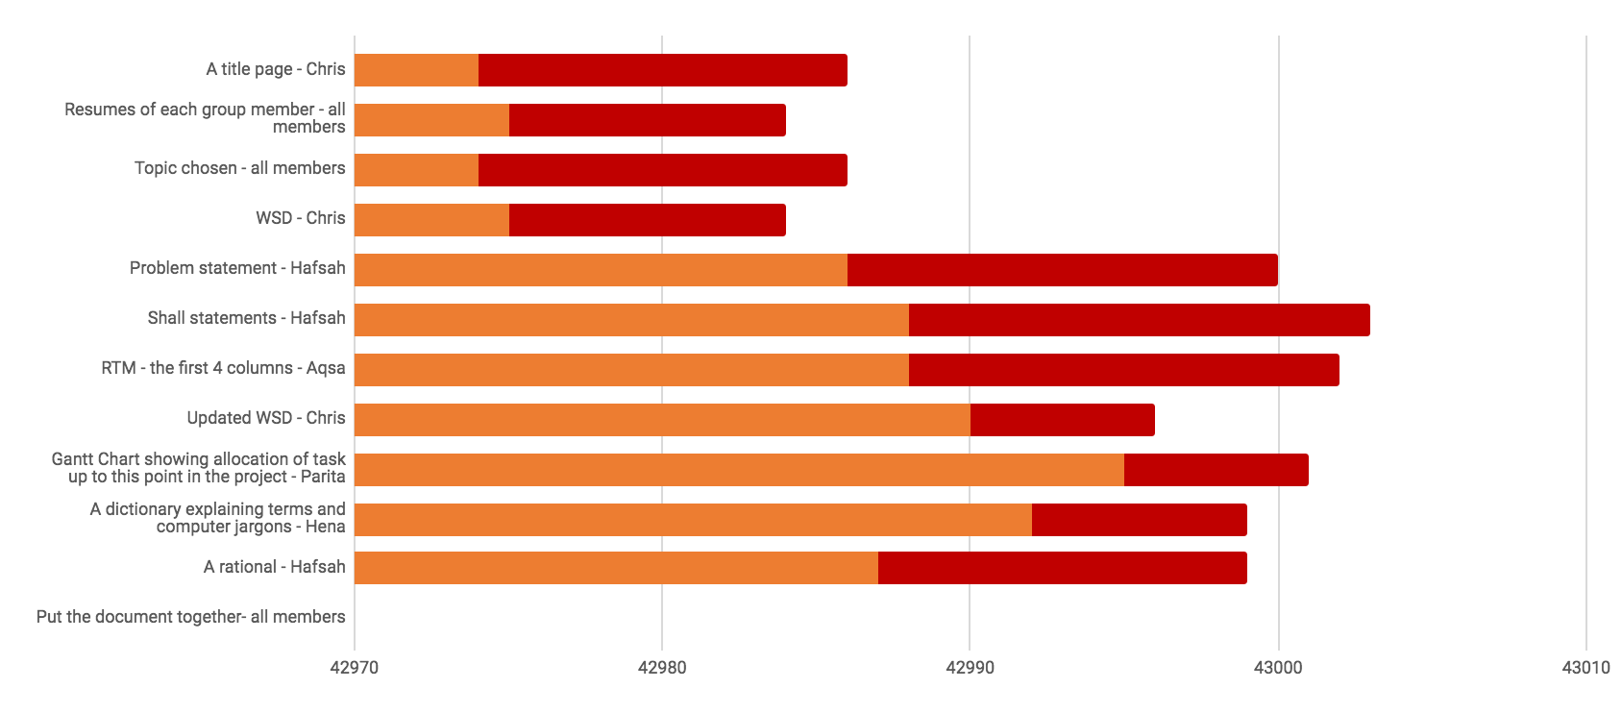

**Dictionary**

* **Raspberry pi:** light weight computer
* **Raspbian:** operating system
* **Java:** most universal coding language
* **Motion Sensor:** detects motion
* **Gesture Sensor:** detects gestures/ hand motions
* **LCD monitor(Liquid Crystal Display):** connects to a computer and shows the display
* **Sleep mode/power saving mode:** when a device or parts of a device are turned off until they are needed again
* **API(Application Programming Interface):** a set of subroutines and tools to build a application software.
* **IP address (Internet Protocol):** a string of numbers that is different for each computer and identifies each computer in order to communicate over a network

**Rationale**

**Issue:** Why was the topic “Magic Mirror” chosen?

When given the assignment we each had our own ideas as to what we wanted to do. Each group member came up with an idea and we voted on which one we wanted to create. We came up with ideas such as: a t-shirt designing software/ website, hotel reservation website, airplane seat reservation website, a game, and a magic mirror. After careful deliberation we decided we wanted to create a magic mirror because since technology is advancing household products can also become technologically inclined. Another reason for choosing this project is that many people were creating websites and apps but we wanted to create an actual product. We saw a few examples of smart mirrors online and were amazed. We wanted to know how it was created and if we could replicate it with additional features.